CENWP-ODJ 7/12/2023

MEMORANDUM FOR THE RECORD

SUBJECT: 23JDA27 Steelhead Mort in NFL

On Tuesday 11 July 2023, at approximately 1500, JDA fisheries personnel noticed several shad morts and a Steelhead mort on the upstream picketed leads in the North Fish Ladder. The shad were cleared off the picketed leads and the steelhead was removed with a net. It was scanned for a PIT tag (no tag) and returned to the river.

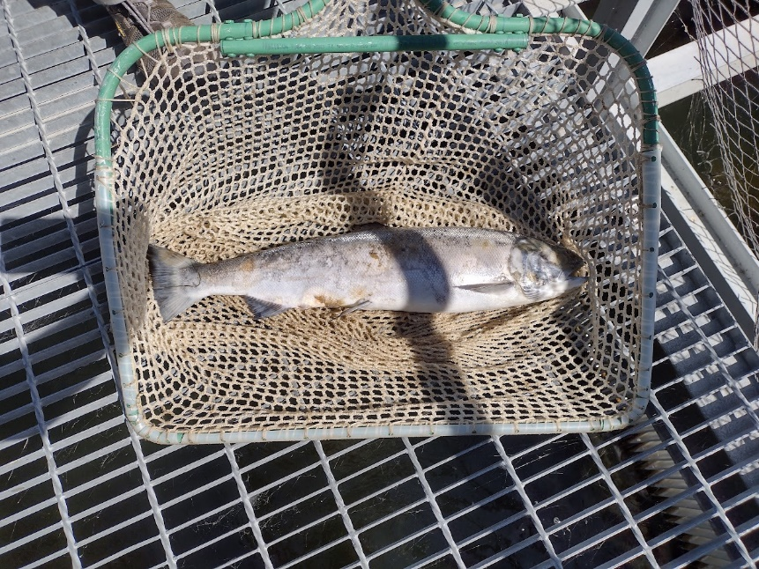

- Species – Steelhead
- Origin – Unclipped
- Length – 26”
- Marks and tags – N/A
- Marks and Injuries found on carcass – Some descaling, fungus
- Cause and Time of Death – Unknown
- Future and Preventative Measures – N/A

Sincerely, Project Fisheries

